Project Proposel for mini project

Topic : Saloon Management System

Group Number : 01

Cluster Number : 03

ICST University Park

September 2024

Students Details

Supervisor Details

Contents

Introduction

Project Background :

The Salon Management system concept has been around for quite some time, but is still in the discussion and design stages. Initially, all inventory and billing reports, appointment scheduling and customer record - keeping were manually managed by the saloon owner/employer using a ledger-based system. This takes a lot of time, double bookings, stock management issues due to repeated accesses to the data. This system increases the risk of data loss or theft. Preserving old data is also an important factor. Shops should reserve a separate room to store this information. Paper-based documents can lose information over time and become completely unreadable after a few years. The Salon Management System is designed to reduce paper- based data storage systems and add a digital touch to billing and inventory systems and user- friendly system.

Salon shop is located in ICST campus 3months ago. When they started small number of workers and customers were connected with them. The shop was started as small shop. This shop provides best services for the customers.

If this business wants to develop further, this shop need a computerized system. In addition, that thing motivated us to create a computerized system. These reasons interact me to undertake this type of project.

Scope :

1. Providing the facility to register regular customers and maintain their details.

2. Generating invoices through the system.

3. Handling salon services along with their perspective prices,hours.

4. Gethering reports supporting the higher managerial decisions.

5. Providing services with satisfaction.

Problem Identification (SWOT ANALYSIS)

1. STRENGTH:

* Convenient location: As the salon is located inside the university it’s easy for students to cut their hair and this will save their time.
* Low cost: usually universities were providing student friendly prices which is a major advantage for students to manage their budget.
* Community programs: offering workshops and seminars for students about the salon system.

1. WEAKNESS:

* Limited customers: there will be only students as customers and this will affect their business profit.
* No proper time management: as the customers were low there won’t be a proper time to open and close the salon and this might cause problems for students to manage their schedule.
* Limited budget: universities have restriction about promoting business advertisements so this is harder to promote their business well and to gain more profit.
* Student’s tight schedule: business can slow down during exam periods or on vacation time’s so this will affect the target profit amount.

1. OPPORTUNITIES:

* Partnership with local business: collaborating with other organization can increase more customers often.
* Feedback: getting feedback from students will make it easy to improve the service according to their preferences.
* Online booking: by implementing online booking system will make it easy for proving a best service without any inconvenience.

1. THREATS:

* Negative review: if anyone one of the students gave negative review that will affect the business.
* Change in trends: student’s passion about fashion will change according to the trend and so the barber should know the fashion trends.

Economic low: if student’s faced budget problem then they will prioritize their other needs more than this so this will affect the business.

Aim and Objectives

**Aim**

The primary aim of a salon system is to create an efficient, user-friendly platform that manages and automates the operations of a hair salon. This includes scheduling appointments, managing customer data, tracking services provided, and optimizing staff and resource allocation, while delivering a seamless experience for both customers and salon staff.

**Objectives:**

1. Appointment scheduling:

A customer is able to easily book, reschedule, or cancel appointments online or through a mobile application to minimize errors in handling and save time.

1. Customer management:

It maintains an all-inclusive database of customer profiles, including haircutting preferences, service history, and contact numbers to provide personal service.

1. Service Tracking:

Keep records of services rendered to each customer, including stylists involved, time spent, and products used, ensuring accurate billing and inventory management.

1. Inventory management:

Track usage and availability of hair products, tools, and other supplies, automatically updating stock levels and generating restock alerts when necessary.

1. Staff management:

Monitor staff availability, skills, and performance to ensure proper allocation of stylists based on customer needs and reduce wait times.

1. Payment and Billing:

Facilitate smooth payment processes, including generating invoices, supporting various payment methods, and offering promotional discounts or loyalty programs.

1. Analytics and Reporting:

Generate reports on sales, customer satisfaction, and staff performance to help salon managers make data-driven decisions and optimize overall operations.

1. Customer Feedback:

Provide a platform for customers to give feedback on their experience, allowing the salon to continuously improve its services.

Project Description

Under our program called Salon Management System we will implement this program based on several objectives. This project is a new software project that can be developed in the university. The objectives of this scheme may be mentioned as follows.

* Facilitate registering regular customers and maintaining them exclusively.

* Customer must pay the full bill amount at the time of receiving the service. Bill payments are fully recorded in the computer.

* Customer is also allowed to pre-book, reschedule and cancel online.

* Simplify appointment management, such as viewing appointments and holidays through an event calendar. Then deal with salon services with respective prices, timings etc.

* Customers can make calls directly to the salon. Also priority will be given to customers who have made a reservation.

* One of the objectives of the program is to collect and analyze customer feedback to improve service quality and establish direct communication between customers and salon management.

* The program is based on service monitoring, tracking the status of current services, and efficiently managing queues while reordering and processing detailed self information.

Overall the salon management system significantly improves the operational efficiency of the salon. and provide valuable insights for business development. The project will also provide a seamless and modern experience for salon staff and customers.

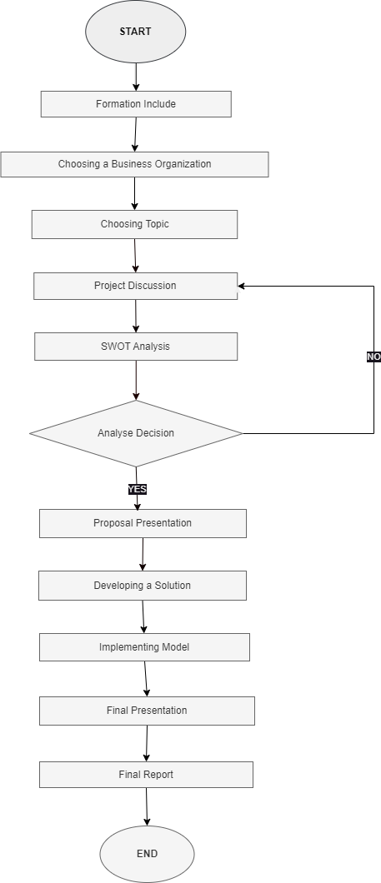

Resources Needed

Individual contribution